**OverTheWire Bandit - Level 9 to Level 10 Writeup**

**Introduction**: This writeup documents my experience solving Levels 9 to 10 of the OverTheWire Bandit challenge, a CTF-style game focused on learning about security concepts.

**Author**: Misha Jain

**Date**: October 19, 2023

**Tools Used:**

Terminal (SSH client)

**Challenge Description:**

Level 9 to Level 10 of Bandit involves connecting to a remote server via SSH and finding a password stored in the file "data.txt." The password is one of the few human-readable strings in the file and is preceded by several '=' characters.

**Enumeration:**

For Level 9, we need to connect to the server using the credentials we obtained in Level 8. Our goal is to find a password stored in the "data.txt" file within a specific format.

**Exploitation - Level 9:**

To connect to the server for Level 9 using SSH, we use the provided credentials:

ssh bandit9@bandit.labs.overthewire.org -p 2220

Use the password obtained from Level 8, which is EN632PlfYiZbn3PhVK3XOGSlNInNE00t to gain access.

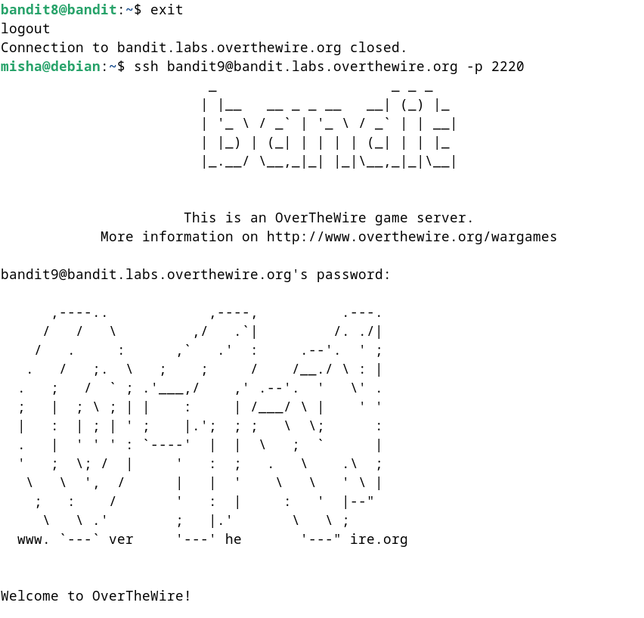

**Password Retrieval - Level 9:**

The password for Level 10 is stored in the file "data.txt" in one of the few human-readable strings and is preceded by several '=' characters. To find this password, we can use the grep command with a regular expression to match the format.

strings data.txt | grep “=”

These commands will display the Level 10 password.

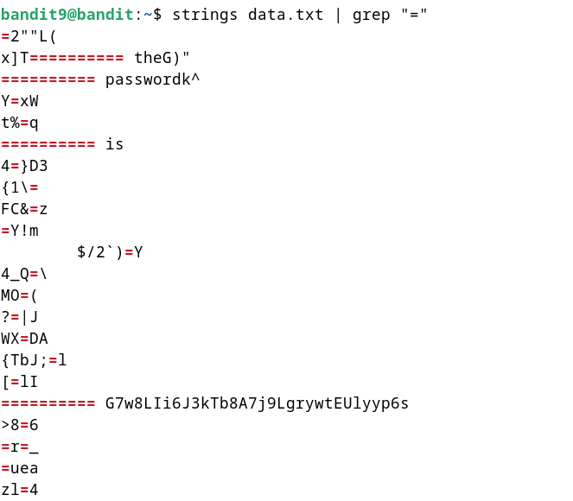

**Password – Level 10:**

The password for Level 10 is: G7w8LIi6J3kTb8A7j9LgrywtEUlyyp6s

**Exploitation – Level 10:**

Now that we have the Level 10 password, we can connect to the server for Level 10 using SSH:

ssh bandit10@bandit.labs.overthewire.org -p 2220

Use the Level 10 password to gain access.



**Lessons Learned:** Level 9 to 10 introduced us to using the grep command with regular expressions to extract specific text patterns from a file. This level reinforced the use of text processing commands to search and manipulate file content.

**Conclusion:**

Levels 9 to 10 of the OverTheWire Bandit challenge continue to build on shell command knowledge while introducing new challenges involving text processing and pattern matching within files. These levels are suitable for beginners to learn more about file manipulation and data extraction.